Class Test 05
PL/SQL
To solve the following use the scott schema

- Create a cursor that can output all the data from salgrade table.

- Create a record that can output the id, name, job, and hiredate of the employee whose Id is 7654.

- Create a trigger in such a way that whenever a new row is inserted into the salgrade table an output ‘New Row Added’ is generated.

- Create a package that contains a procedure which can display the grade whose losal and hisal is passed as its parameter.

**After solving the above questions using Oracle 10g, write the PL/SQLs in a MS Word document (Write down the answer and give screenshot of the result of the query. The name of the document MUST be your ID and the PL/SQLs MUST be numbered accordingly) and upload it in the provided link in your VUES account

1. Create a cursor that can output all the data from salgrade table.
DECLARE
CURSOR c_salgrade IS
SELECT * FROM salgrade;
v_row salgrade%ROWTYPE;
BEGIN
OPEN c_salgrade;
LOOP
FETCH c_salgrade INTO v_row;
EXIT WHEN c_salgrade%NOTFOUND;
DBMS_OUTPUT.PUT_LINE(
'Grade: ' || v_row.grade ||
' | Low Salary: ' || v_row.losal ||
' | High Salary: ' || v_row.hisal
);
END LOOP;
CLOSE c_salgrade;
END;
/
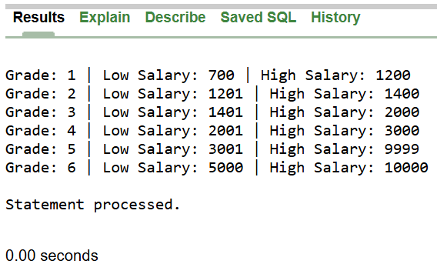

2. Create a record that can output the id, name, job, and hiredate of the employee whose Id is 7654.
DECLARE
emp_rec emp%ROWTYPE;
BEGIN
SELECT * INTO emp_rec FROM emp WHERE empno = 7654;

DBMS_OUTPUT.PUT_LINE('Employee ID: ' || emp_rec.empno);
DBMS_OUTPUT.PUT_LINE('Employee Name: ' || emp_rec.ename);
DBMS_OUTPUT.PUT_LINE('Employee Job Title: ' || emp_rec.job);
DBMS_OUTPUT.PUT_LINE('Employee Hire Date: ' || emp_rec.hiredate);
END;
/
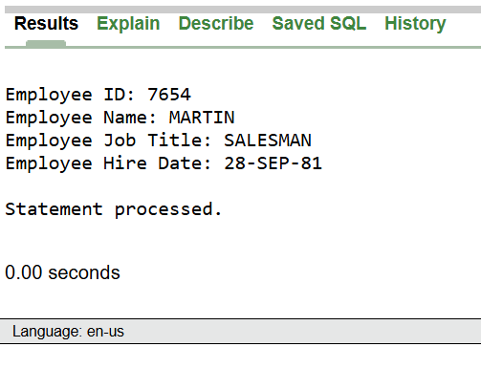

3. Create a trigger in such a way that whenever a new row is inserted into the salgrade table an output ‘New Row Added’ is generated.
CREATE OR REPLACE TRIGGER salgrade_added
AFTER INSERT ON salgrade
FOR EACH ROW
BEGIN
dbms_output.put_line('New Row Added');
END;
/

INSERT INTO salgrade (grade, losal, hisal) VALUES (6, 5000, 10000);

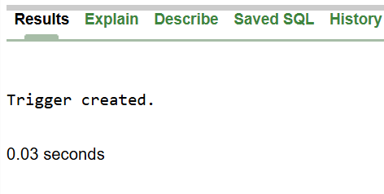
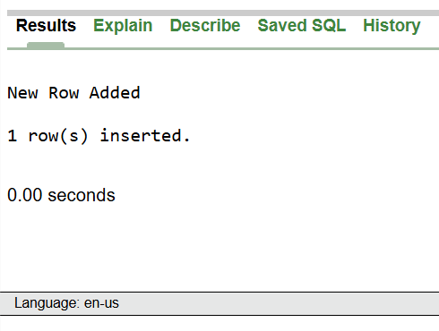

4. Create a package that contains a procedure which can display the grade whose losal and hisal is passed as its parameter.
CREATE OR REPLACE PACKAGE grade_pkg AS
PROCEDURE display_grade(
p_losal IN salgrade.losal%TYPE,
p_hisal IN salgrade.hisal%TYPE
);
END grade_pkg;
/

CREATE OR REPLACE PACKAGE BODY grade_pkg AS
PROCEDURE display_grade(
p_losal IN salgrade.losal%TYPE,
p_hisal IN salgrade.hisal%TYPE
) IS
v_grade salgrade.grade%TYPE;
BEGIN
SELECT grade INTO v_grade
FROM salgrade
WHERE losal = p_losal
AND hisal = p_hisal;

DBMS_OUTPUT.PUT_LINE('Grade for losal ' || p_losal || ' and hisal ' || p_hisal || ' is: ' || v_grade);
EXCEPTION
WHEN NO_DATA_FOUND THEN
DBMS_OUTPUT.PUT_LINE('No grade found for the specified losal and hisal.');
END display_grade;
END grade_pkg;
/

BEGIN
grade_pkg.display_grade(2001, 3000);
END;
/


